Evaluation of the organization and activities training course as part of the KA210 Project "GAMECHANGE: Innovative Board Games for Youth Engagement"
We would like to have your opinion about our the training course and game making process, that took place in PISSOURI, LIMASSOL, CYPRUS (HYLATIO TOURIST VILLAGE) regarding the overall training organization and the activities we had; educational, cultural and others.
The questionnaire is divided in five sections and we would like to gather your feedback because your opinion is important to us and will also help us to improve. This questionnaire is only for participants AND LEADERS in the training.
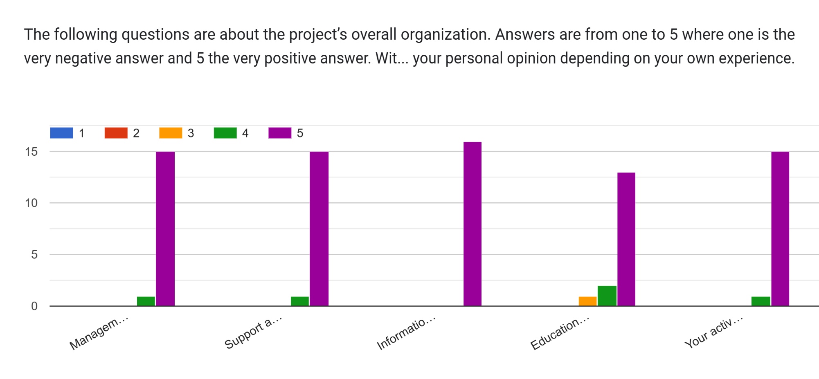
Do u want to mention anything about management or information sent and other organizational themes of the project?
No  it was very good organized thank you | All good | No.  no

Any comments about the activities?
Its was very interesting  Too many for the short time. We felt in a constant rush, but I understood that is because of the lack of participants. | i loved them  no  No | Some of them could be combined and more days for this kind of proiect will be great in the future.
Any additional comments?
Totally unprofessional trainers and totally out of the topic. No added value, in fact some times their advices or suggestions created more confusion in the team. I highly do not recommend them to do this type of activities again, in special the women. | No.  no, thanks you for everything  No
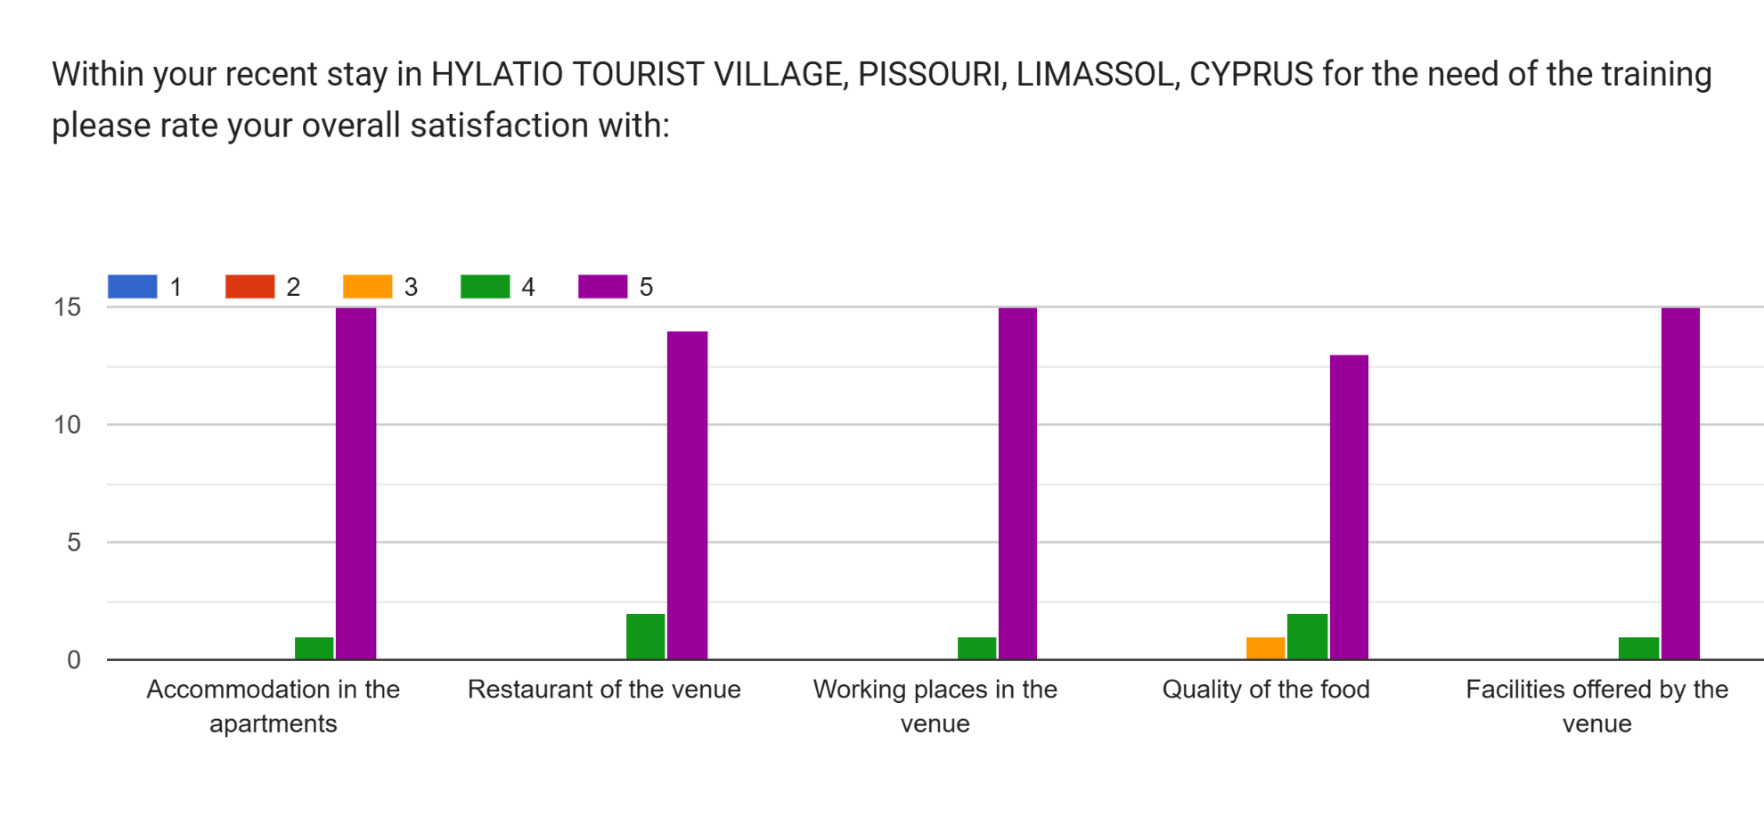
Anything that you want to mention in particular that will make us better about our future projects which have to do with the accommodation place and the food in the project
It was amazing | No. They were great. | In food there was a lot of fat | All perfect

Non-Formal Section Educational Activities
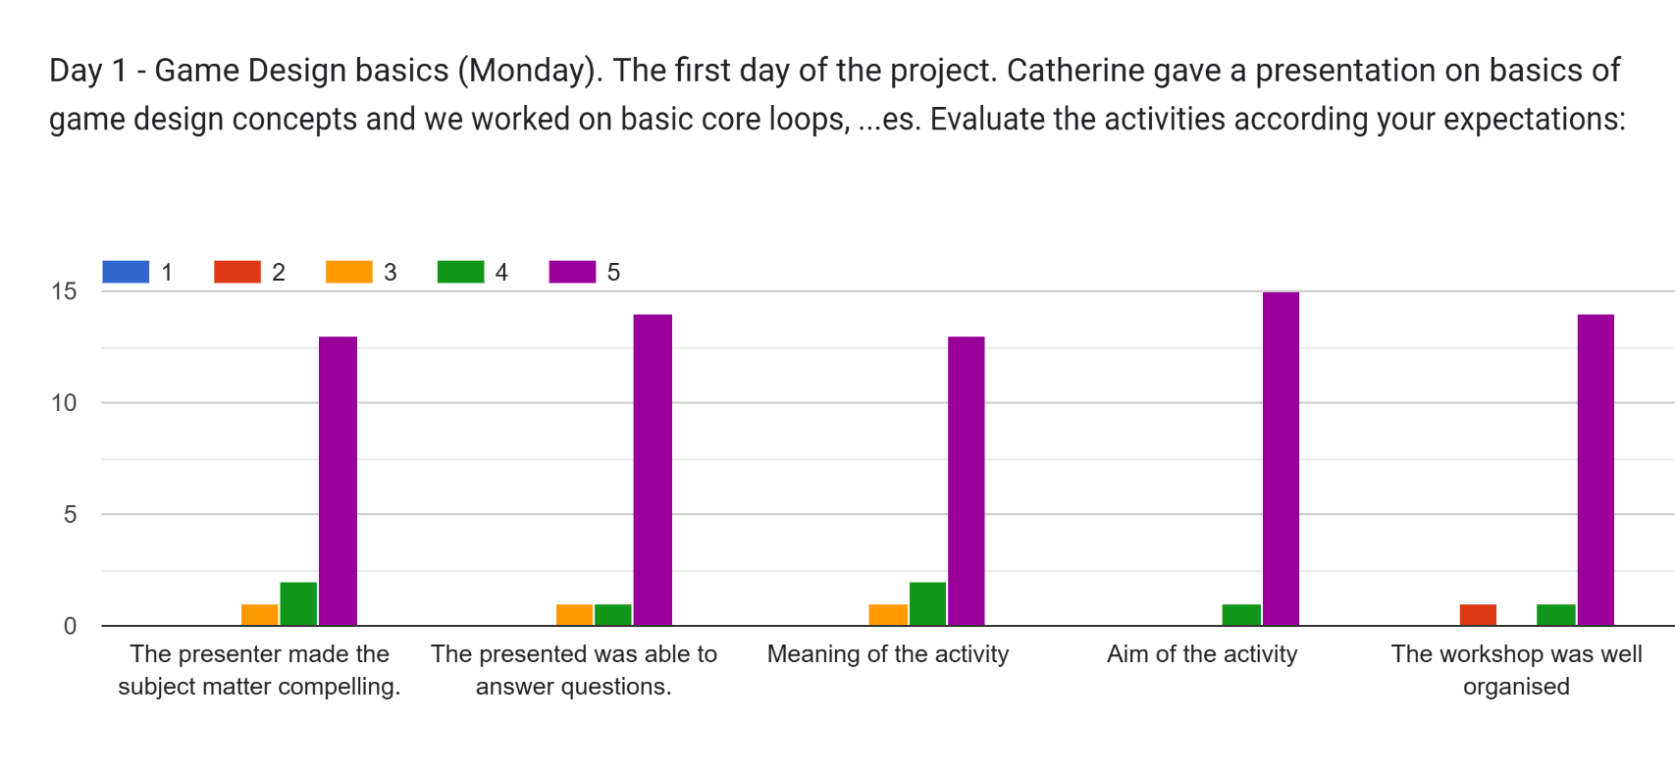
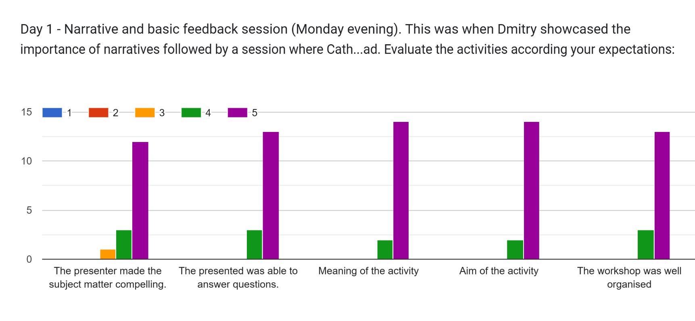
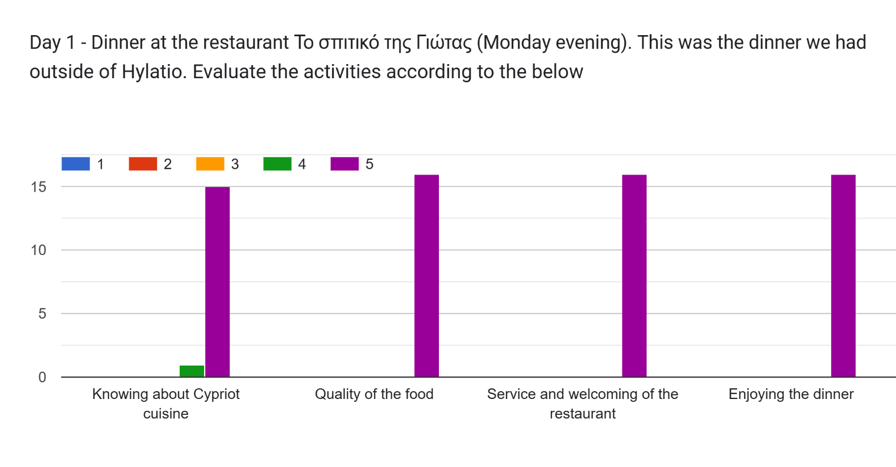
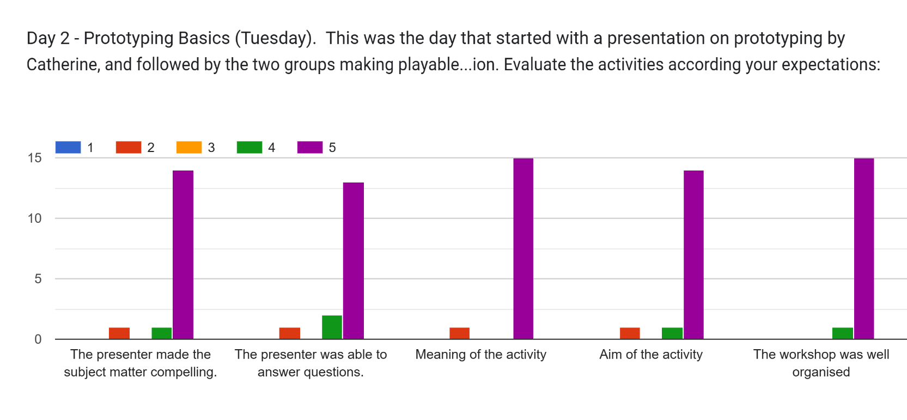
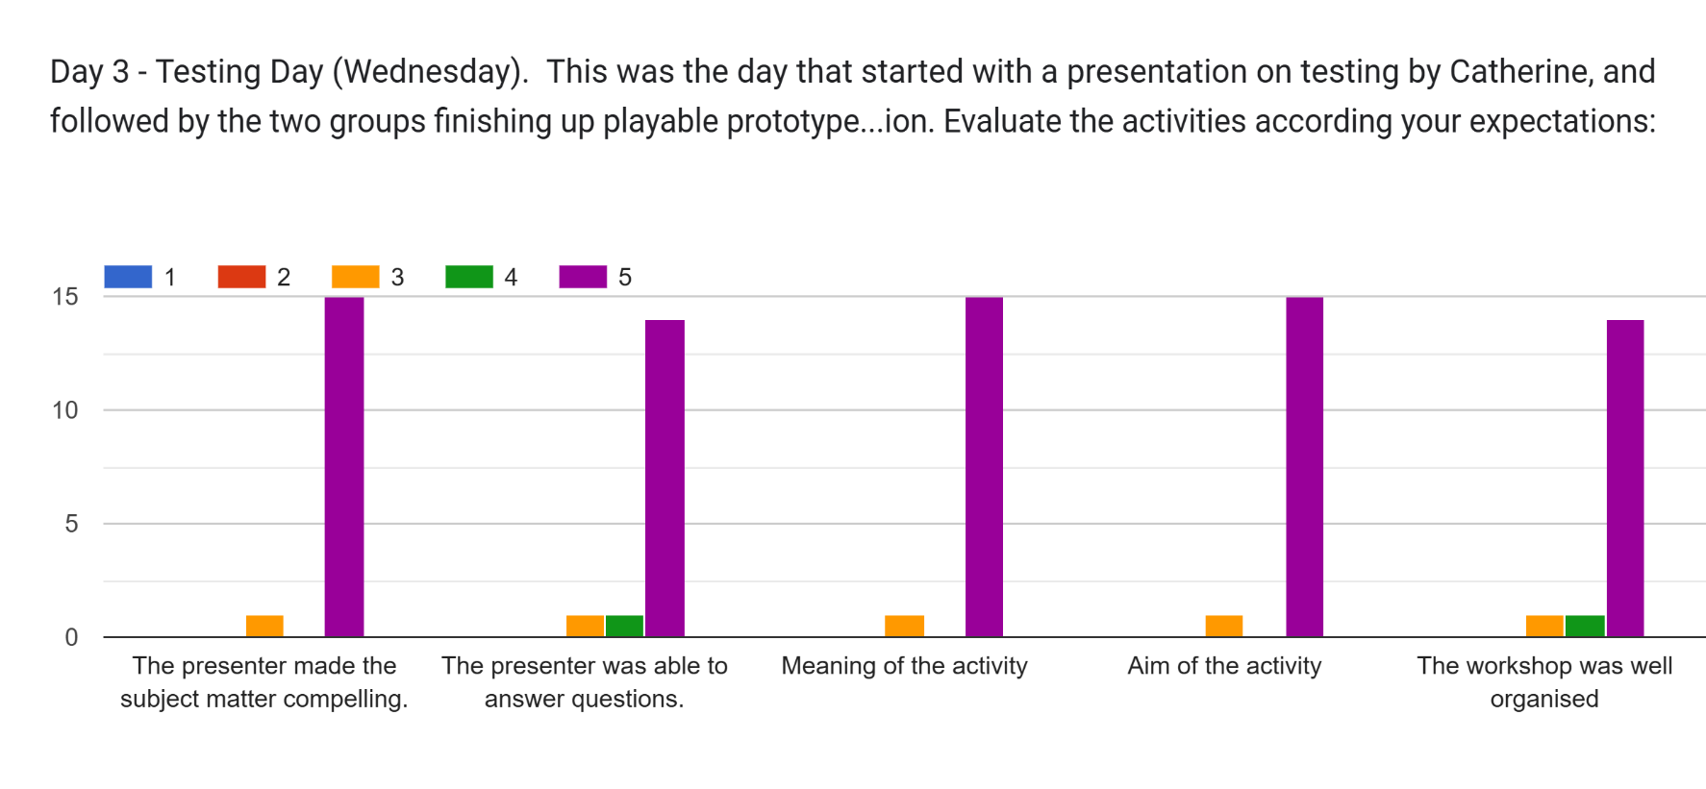
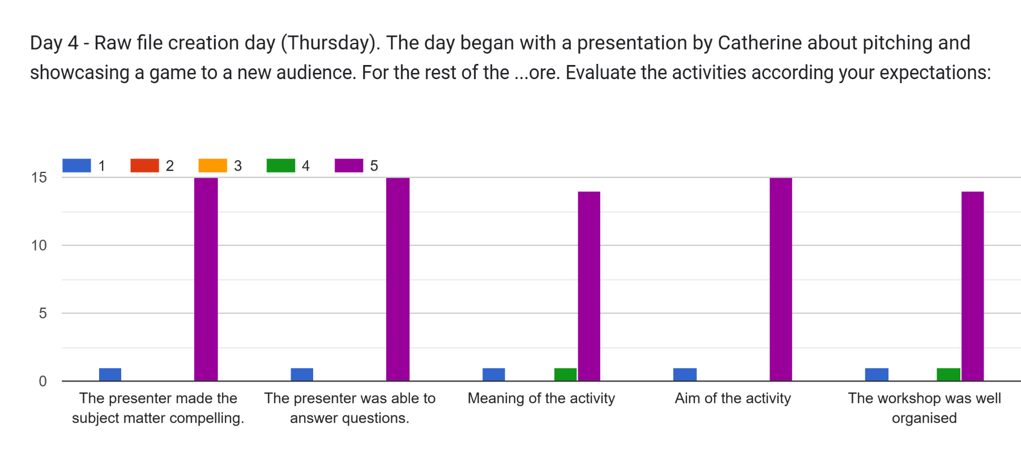
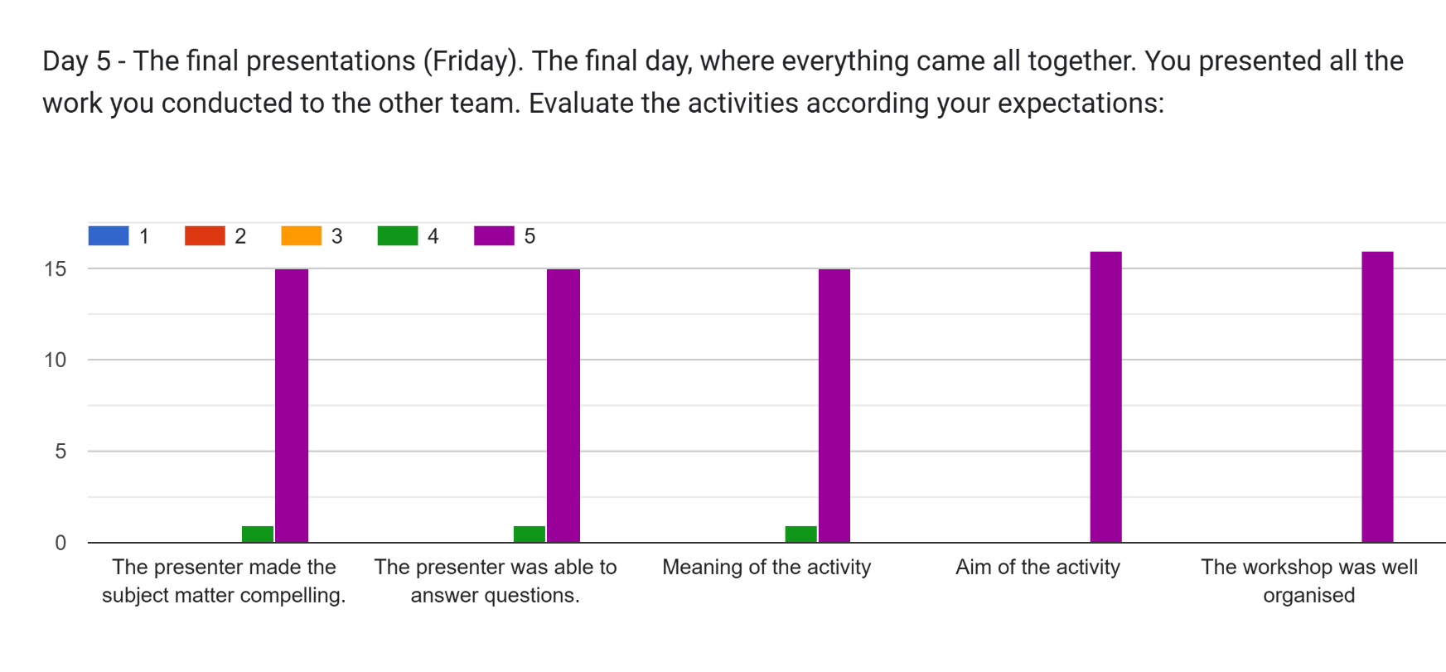
Write your emotional outcome for the organisation and implementation of the training
Project was well organised  Great  Very happy for what we made  i am better now in working with teams from other countries  <3  I really enjoyed the process of designing a board game. | i loved all  For me i had felling i am working with profesional  I love that we succede in having 2 games.  it was tough but i really enjoyed it. It was exactly how game development is | They are amazing if you have any questions they help  I am happy that we managed to have a final result  i learned to work better in teams even if sometimes there are disagreements:)  learned new technniques | sometimes it was very hard work in our group but and the end im glad to be part of this  I felt good, everything went as it should, I'm very happy with the results of how both games turned out.
Which aspect had the maximum impact for you?
When we made a video  The one where we worked in teams by ourselves  The testing part, web designing and the prototype of the game.  we made game together | I'm proud that I really created a really fun game here and I especially like that the digital part turned out well.  every activity. i learned to be better youth worker  all | prototyping  To split into the groups and create the game  All  Team work  digital stuff like marketing  teamwork | Presentstion Katerine and Dimitry  The project overall. I always dreamed of making games. Even though it s not perfect, it is a great start
Which activity if any had the least impact for you?
All activities well organised and interesting  Designing the game  all of the activities had impact for me | advert making  The narration part.  describing the rules of the game  Prototype | Pitch and prototype because we we received the information after we had the task to create them in teams.  None | Dinner in restaurant  I was invested in all of them  all had impact  We're not related with our progress status
Any remaining comments?
No
❤️
thank you acpelia team

